**SMART INTRUSION DETECTION SYSTEM FOR CROP PROTECTION USING ESP32**

**By**

**AKSHAYA K V**

**KAYALVIZHE J**

**MIRDULAA A**

**Report submitted in partial fulfilment of**

**the requirements for the Degree of**

**Bachelor of Engineering in Electronics**

**And Communication Engineering**



**Sri Ramakrishna Institute of Technology**

**Coimbatore – 641010**

**November,2022**

**ACKNOWLEDGEMENT**

Behind every achievement lies an unfathomable sea of gratitude to those who actuated it, without them it would never have into existence. To them we lay the word of gratitude imprinted within us.

We would like to express our gratitude to the SNR management Trust and the Principal **Dr. M. Paulraj**, for giving us access to all the necessary technological resources.

We express our gratitude to **Dr. S. Anila**, Head of the Department of Electronics and Communication Engineering for her conscientious guidance and encouragement.

We would like to extend our sincere gratitude to our Project Supervisor,   
**Dr G. Sekar**, Assistant Professor (Sr.Gr.), Department of Electronics and Communication Engineering for his cordial support and guidance.

We would like to extend our sincere gratitude to our Integrated Design Project coordinator, **Dr. S. Mary Praveena**, Associate Professor, Department of Electronics and Communication Engineering for her cordial support and guidance

We sincerely thank all the teaching and non-teaching staff of Electronics and Communication Engineering department for all what they have been for their enquiry about the project.

**APPROVAL AND DECLARATION**

**This project report titled “Smart Intrusion Detection System For Crop Production Using ESP32” was prepared and submitted by Akshaya K V (1904004), Kayalvizhe J (1904030), Mirdulaa A (1904034) and has been found satisfactory in terms of scope, quality and presentation as partial fulfilment of the requirement for the Bachelor of Engineering (Electronics and Communication Engineering) in Sri Ramakrishna Institute of Technology, Coimbatore(SRIT).**

**Checked and Approved by**

**Dr. G. Sekar**

**Project Supervisor**

**Assistant Professor (Sr. Gr.)**

**Department of Electronics and Communication Engineering Ramakrishna institute of Technology,**

**Coimbatore-10**

**November, 2022**

**SMART INTRUSION DETECTION SYSTEM FOR CROP PROTECTION USING ESP32**

**ABSTRACT**

It is mandatory to protect the agricultural field from the entry of animals which causes damage to crops. This problem has been rectified by developing a system which will monitor the field 24x7. This system uses a motion sensor to detect wild animals approaching near the field. In such a case the sensors send signals to the microcontroller to take action. The microcontroller gives an alarm to the farmer to know about the issue and come to the spot in case the animals turn away by the alarm. This ensures complete safety of crops from animals thus protecting the farmers' loss. Our main aim to design a system that can help to farmer to protect his farm from animals without getting harm to them. All the parameters are monitored in crop yield via phone through Internet of things. In this project two sensors namely Ultrasonic and PIR sensors are used to detect motion and the distance of the Intruder.

**TABLE OF CONTENTS**

**Page**

**ACKNOWLEDGEMENT ii**

**APPROVAL AND DECLARATION SHEET iii**

**ABSTRACT iv**

**TABLE OF CONTENTS v**

**LIST OF TABLES vii****i**

**LIST OF FIGURES i****x**

**LIST OF SYMBOLS,ABBREVIATIONS OR NOMENCLATURE xi**

**CHAPTER 1 INTRODUCTION** 1

* 1. Overview 1
  2. History 2
  3. Application 2

**CHAPTER 2 LITERATURE REVIEW** **3**

**CHAPTER 3 PROPOSED METHODOLOGY 9**

* 1. Problem Statement 9
  2. Methodology 9
  3. Scope of the Project 11
  4. Hardware Description 11
     1. ESP32 Microcontroller 11
     2. PIR Sensor 14

3.4.3 [Ultrasonic Sensor 15  
3.4.3.1 Operation 18](#_TOC_250011)

* + 1. Power Supply 19  
        3.4.4.1 Linear Power Supply 19  
        3.4.4.2 Transformer 20   
        3.4.4.3 Rectifier 21 3.4.4.3.1 Bridge Rectifier 22  
        3.4.4.3.2 Single Diode Rectifier 23   
        3.4.4.4 Smoothing 24
    2. Regulator 25
    3. Buzzer 26
  1. Software Description 27

3.5.1 Arduino IDE 27  
 3.5.1.1 Writing Sketches in Arduino IDE 27   
 3.5.1.2 Sketch Book 28  
 3.5.1.3 Uploading code 28   
 3.5.1.4 Libraries 29

3.5.2 Serial Monitor 29

3.5.3 Embedded C 30

3.5.4 Necessity 31

3.5.5 Embedded Systems Programming 32

3.5.5.1 Difference between C and Embedded C 33

3.5.6 Proteus Software 33

3.5.6.1 Introduction 34

3.5.6.2 Language Features 34

3.5.6.3 Synopsis and Licensing 35

**CHAPTER 4 RESULTS AND DISCUSSION** 36

**CHAPTER 5 CONCLUSION** 41

**REFERENCES** 42

**LIST OF TABLES**

**Table No. Page**

3.1 Pin Configuration 15

3.2 Pin Configuration 17

3.3 Specification 17

4.1 Hardware Prototype Output 39

**LIST OF FIGURES**

**Figures No. Page**

3.1 Block Diagram of the Proposed System 10

3.2 ESP 32 Microcontroller 12

3.3 PIR Sensor Module 14

3.4 Pin Diagram of PIR Sensor 15

3.5 Ultrasonic Sensor 17

3.6 Timing Diagram 18

3.7 Power Supply 20

3.8 Transformer 20

3.9 Output Signals 21

3.10 Rectifier 22

3.11 Bridge Rectifier 22

3.12 Output Waveform 23

3.13 Single Diode Rectifier 23

3.14 Output Signals 24

3.15 Smoothing Effect 24

3.16 Power Supply 25

3.17 Regulator 26

3.18 Output Power supply with signals 26

3.19 Buzzer Circuit 27

3.20 Sketch Diagram 29

4.1 Hardware Prototype Model 39

4.2 Implementation and results of Hardware Prototype

Model 39

4.3 Software 40

**LIST OF SYMBOLS, ABBREVIATIONS OR NOMENCLATURE**

DC - Direct Current

AC - Alternate Current

PIR - Passive Infrared

ESP - Electronic Stability Control

GSM - Global System for Mobile Communication

TFT - Thin-film Transistor

ADC - Analog to Digital Converter

IOT - Internet Of Things

**CHAPTER 1**

**INTRODUCTION**

It is obligatory to defend the rural subject from the access of animals which reasons harm to plants. This hassle has been rectified via way of means of growing a machine on the way to reveal the sphere 24x7. This machine makes use of a movement sensor to discover wild animals drawing near close to the sphere. In one of these cases the sensors ship indicators to the microcontroller to take action. The microcontroller offers an alarm to the farmer to recognize approximately the difficulty and are available to the spot in case the animals pull away via way of means of the alarm. This guarantees whole protection of plants from animals for that reason defensive the farmers' loss. Our foremost purpose to layout a machine which could assist to farmer to defend his farm from animals without getting damage to them. All the parameters are monitored in crop yield through telecall smartphone via Internet of things. In this assignment sensors particularly Ultrasonic and PIR sensors are used to discover movement and the gap of the Intruder. The Proposed machine is articulated to the factor that now and again the farmer chooses to depart the territories barren because of such incessant animal assaults. India is especially relied on agriculture and 70% of India’s profits is from agriculture. In this assignment the version which prevents harm to plants is being advanced. This machine is advanced with the assist of embedded System layout the usage of Wifi technology. The foremost purpose of this assignment is defensive the crop from wild animals via way of means of the usage of PIR sensor. Agriculture is India ‘s maximum critical monetary sector. Though most populace of India relies upon on agriculture, there are numerous troubles confronted via way of means of farmers. Problem because of wild animals is a chief hassle wherein huge wide variety of plants receives spoiled because of this wild animal. So, this one is to be watched constantly to save you access of the animals or some other unauthorized access. Elephants or wild pigs enters agricultural subject searching for nutritious food. Need of the animal or human imposes actual danger, on this process, plants are spoiled and once in a while even there may be a demise can occur. Human-elephant warfare is extra in south Asia and in Africa. Usually, the approach is used to defend farm is painful to the animals. Which makes animals behave atypical and reasons extreme harm to resource. To enhance agriculture because the survival of the fittest, wild animals that input the sphere may be constantly monitored and redirect them via way of means of the usage of sound. Along with this hearthplace sensor is introduced to keep away from the spreading of hearthplace from forestry regions to the agriculture.

**1.1. Overview**

Agriculture is the economy's cornerstone, however animal intrusion in farm fields can bring about principal crop losses. Their methods aimed entirely at human intruders; the access of untamed animals has ruined many village farms. Farmers' conventional strategies are ineffective, and it isn't always realistic to hire guards to hold a watch on plants and hold wild animals at bay. As a result, many farmers face economic problems and are pressured to relocate because of repeated animal assaults. Crops in farms are commonly ravaged via way of means of neighborhood animals like buffaloes, cows, goats, birds etc. This results in massive losses for the farmers. It isn't always viable for farmers to barricade complete fields or live on subject 24 hours and defend it. This module assists us in maintaining wild animals out of farmlands, and it's miles frequently computerized primarily based totally at the want, which means there may be no employee involved, saving time and keeping off crop loss.

**1.2 History**

Agriculture continues to be one of the maximum important sectors of the Indian economy. It is critical for human survival in addition to monetary growth. Traditional structures like humanoid scarecrows are used even nowadays in an agricultural subject to prevent birds and animals from traumatic and feeding on developing plants. Electric

fencing is one technique of defensive plants from wild animals, in different regions, farmers burn elephant dung or different substances that combust and bring thick smoke, inflicting air fine troubles. There are many loopholes in such thoughts and so improving agricultural safety has end up a chief difficulty those days.

Thus, an opportunity answer is created which detects the intruders, video display units any malicious interest after which reviews it to the proprietor of the machine. It acts as an adaptable machine which presents a achievable machine to the farmers for making sure whole protection in their farmlands from any assaults or trespassing activities.

**1.4 Applications**

In the cutting-edge era, the complexity of agricultural structures and the want to satisfy a couple of targets in sustainable agro-ecosystems name for interdisciplinary analyzes and enter from a extensive sort of disciplines which will higher recognize the whole agronomic manufacturing machine. The digital digicam constantly video display units the fields. Acting because the mind of the machine, the ESP 32 microcontroller constantly tests for the movement withinside the subject or orchard. If any form of movement is detected withinside the subject, tests for the presence of animals withinside the image. If any animal is found, it presents actual-time pics of the sphere over the internet, which may be regarded via way of means of the usage of an internet browser on gadgets like laptop and cellular and additionally it indicators the encircling humans via buzzer sound.

**CHAPTER 2**

**LITERATURE SURVEY**

* Srushti Yadahalli, Aditi Parmar, Prof.Amol Despande, “Smart Intrusion Detection System for Crop Protection by using Arduino,” Proceedings of the Second International Conference on Inventive Research in Computing Applications(ICIRCA 2020).

Agriculture is still one of the most crucial sectors of the Indian economy. It is important for human survival as well as economic growth. Traditional systems like humanoid scarecrows are used even today in an agricultural field to stop birds and animals from disturbing and feeding on growing crops. There are many loopholes in such ideas and so enhancing agricultural security has become a major issue these days. Thus, this paper focuses on proposing a system which detects the intruders, monitors any malicious activity and then reports it to the owner of the system. It acts as an adaptable system which provides a practicable system to the farmers for ensuring complete safety of their farmlands from any attacks or trespassing activities. Agriculture meets food demands of the population and also provides various raw materials for industries. Interference of animals in agricultural lands causes a huge loss of crops. Crop damage due to raiding wild animals has become a major issue of concern these days. Animals like wild boars, macaques, porcupines, deer, monkeys and bears are extremely destructive and have also caused human casualties sometimes. The total losses in crop yield are high for potato and wheat in villages. Small farmers lose up to 40 to 50 percent of their crop to wild animals and they cannot take any harsh measures due to the strict wildlife laws. Human-elephant conflict is rising intensely as elephants are a highly conflict prone wildlife species, especially in India. Thus, there is need for a system which can help the farmers to drive away these animals as soon as they learn about their intrusion. In this system there are three levels of alerts: low, moderate and high, according to which the extent of danger imposed by the intruder can be easily ascertained. The placement of the Passive Infrared (PIR) sensor is in such a way that it gives a wider range for detection. Thus, the novelty of the paper lies in the availability of a Thin Field Transistor (TFT) display acting as a visual alarm which can be seen by the other villagers as well and they can protect the farm in case there is a delay in the arrival of the farmer. The pixel control feature of the TFT display gives the advantage of clearer pictures as output. Global System for Mobile Communications (GSM) module is used for transmission of information to farmer. In this paper, initially a glimpse of an existing system is given followed by the hardware description of the proposed system. Objectives and scope explain the aims of the system and the purpose of implementation of different components. The proposed methodology explains the working of the system in detail followed by the block diagram and flowchart which gives us a clearer idea about the system. The paper also elaborates on the benefits of the proposed system. As an addition to the project, an IoT network can be used for cloud computing method for the connection and management of devices. Along with this, the range of applications can also be increased to home automation in both urban and rural areas so a greater part of the population can utilize IoT in their day-to-day life. Also, the range of protection can be extended to protection of crops from the damage caused by birds as the damage caused by them can have a significant impact when continued for long periods of time.

* S. Pandey and S. B. Bajracharya, “Crop protection and its effectiveness against wildlife: A case study of two villages of shivapuri national park, nepal,” Nepal Journal of Science and Technology, vol. 16, no. 1, pp.1–10, 2015**.**

A complex relationship between the residents and protected areas continue to be an obstacle to successful conservation of protected areas. Conflicts between park authority and people living around the park pose a threat to conservation. Moreover, crop depredation due to wildlife incurs a severe economic loss to communities living in the close vicinity of the park, affecting the livelihood and well-being of locals. Many studies have been carried out emphasizing the identification and quantification of crop damage, but studies highlighting the means used for the crop protection and their effectiveness are limited. This paper examines frequency of the crop damage by wildlife and efficacy of utilized management practices in Shivapuri National Park (SNP). Altogether 132 households were visited in two buffer zone villages namely, Sikre and Jhor Mahankhal of Shivapuri National Park, Nepal. The study suggested that crop depredation by wildlife was a function of several factors, namely, distance of the farmland from the park, size of the crop raiding animals, frequency of their attacks on the farmland, and the type of crops. Five different measures were identified by the communities which they regularly used to prevent crop damage. Both traditional as well as modern means were used by households to guard crops from invading wild animals. The means of crop protection from wildlife differed according to the type of animal and crop being protected. Biofencing and trenches were effective for the small animals. Watch tower “Machans” and throwing flaming sticks and making noises were the most effective and safest means of crop guarding from all kind of animals. Though crop guarding was intensive, no means were found to be able to prevent crop damage completely. Thus, site specific management strategies as well as technical and financial support from donor organizations would be most useful to minimize crop loss Issues such as loss of extraction rights and losses due to wildlife interferences and lack of or limited financial compensation have been highlighted as the root causes of conflict between the local communities and conservation programmes (Baral & Heinen 2007, Hill 1998, Karanth 2003). Similarly, illegal livestock grazing inside the park and transaction of forest products causes this imbalanced relationship (Studsord & Wegg 1995, Tamang & Baral 2008, Shrestha 1994). Among all these issues, damage to crops, livestock, property and also human life because of wildlife interferences have been regarded as one of the severe problems faced by protected areas. worldwide (Heinen 1993, Nyhus et al. 2000, Perez & Pacheco 2006, Rao et al. 2002, Weladji & Tchamba 2003). Park-people conflicts due to wildlife interference in the livelihood of communities often jeopardize the relationship between local communities and the protected area itself. This deteriorating relationship between two key stakeholders threatens the long-term management of protected areas. The damage to field crops caused by wild animals has been a highly topical issue and also one that has been discussed publicly. It was found that crop varieties, distance of the farm from the park boundary, and the surrounding ecology were the main factors in crop damage variation. Although different means were used to prevent crop damage, most of the means were only temporarily effective as animals were only driven away for few minutes to be expected to come back after things were quiet. Different means including traditional and modern means were used for different types of animals which implied no single means could be employed to all the villages. This highlights the need for site-specific management techniques to minimise the crop damage problem by wild animals. As households stated, a few crops avoided by wildlife provide economic benefits, park management should conduct further research on sustainability of those crops. In addition, exchange of information among farmers about different mitigating means, and a learning process within the park management could help to minimise the crop damage problems. Studies show that using different activities to effectively mitigate crop raiding and seem to be an appropriate response strategy.

* V. Bavane, A. Raut, S. Sonune, A. Bawane, and P. Jawandhiya, “Protection of crops from wild animals using intelligent surveillance system.”

Animal attacks in India are a common story nowadays. Due to the unavailability of any detection system these attacks kill villagers and also destroy their crops. Due to lack of proper safety measures, these villagers are left helpless to their fate. Therefore a proper detection system could help save their lives and also to the preservation of crops. Also the crops of villagers are destroyed due to frequent interference of animals. The crops and paddy fields cannot be always fenced. So the possibility of crops being eaten away by cows and goats are very much present. This could result in huge wastage of crops produced by the farmers. To make the best use of mobile communication technology, the objectives of this paper therefore utilizes global system for mobile communication (GSM) and provide short message service (SMS). This system helps us to keep away such wild animals from the farmlands as well as provides surveillance functionality. It has been found that the odor of rotten egg helps to keep the wild pigs and deer from destroying the crops, hence the farmers manually spray the rotten egg solution on their fields, and firecrackers are used to ward off the wild elephants that destroy the crops.This project is based on surveillance with an animal ward-off system employed in farmlands in order to prevent crop vandalization by wild animals. In addition to providing protection this system distinguishes between an intruder and an authorized person using RFID’s, various PIR sensors are deployed in the area to detect any motion and hence turns ON a camera when movement is detected, thereby providing real time monitoring. The problem of crop vandalization by wild animals has become a major social problem in the current time. It requires urgent attention and an effective solution. Thus this project carries a great social relevance as it aims to address this problem. Hence we have designed a smart embedded farmland protection and surveillance based system which is low cost, and also consumes less energy. The main aim is to prevent the loss of crops and to protect the area from intruders and wild animals which pose a major threat to the agricultural areas. Such a system will be helpful to the farmers in protecting their orchards and fields and save them from significant financial losses and also saves them from unproductive efforts that they endure for the protection of their fields. This system will also help them in achieving better crop yields thus leading to their economic wellbeing.

* R. Vigneshwar and R. Maheswari, “Development of embedded based system to monitor elephant intrusion in forest border areas using internet of things,” International Journal of Engineering Research, vol. 5, no. 7, pp. 594–598, 2016.

The new era of computing technology is emerging as it will encompass every aspects of our lives with amazing potentials and it can be termed as Internet of Things (IOT). The IOT generally comprised of smart machines interacting and interactive with other machines, objects, environments and infrastructures. In embedded computing system each thing is uniquely identifiable but it is able to be interoperable within the existing internet infrastructure in IOT. As a result, massive volumes of data are being created, and that data is being processed into useful actions that can “command and control “things to make our living much comfortable and safer and to ease our impact on the environment. In this paper we have proposed a elephant intrusion monitoring system using IOT. The various drawbacks in already existing system using embedded systems can be overcome as we have cloud-based services, low cost and advanced miniaturization in packaging technology. Here we are developing a prototype model for real time interaction of elephant intrusion in forest border areas that allows a persistent monitoring by making use of an On board computer and cloud services. In our proposed system, the main aim of our work is to alert the people in and around the forest border areas and to prevent their lives. Here, we are developing a prototype model for a real time interaction of elephant intrusion in forest border areas by making use of Internet of Things (IoT). New hardware platforms make embedded systems in IoT applications easier to engineer than ever before. Once you have preferred the hardware platform, however, you still must improve the application software, and that is where further decisions must be made. Not so very long ago, your superior of programming language was smart much uttered by your choice of hardware platform. More new platforms that are created on open-source standards and able to maintain multiple languages make more flexibility. One of the key culture platforms for IoT is the Raspberry Pi. The Raspberry Pi is a sequence of credit card sized single-board computers established in United Kingdom by the Raspberry Pi Foundation with the purpose of promoting the coaching of basic computer science in schools and developing countries. The Raspberry Pi is a widespread platform because it offers a total Linux server in a little platform for a very low cost.

**CHAPTER 3**

**PROPOSED METHODOLOGY**

**3.1 Problem Statement**

In the proposed device, Crop tracking is carried out in which sensors are used to gather records with inside the agricultural discipline. In our propose paintings, ESP32, Motion Detecting Sensor and GSM is used. When animals come close to the movement detecting sensor and it detects the animal motion. After getting that preliminary enter sign, its miles handed for similarly processing. Then it'll be given to the esp32. Our device may be activated, at once buzzer may be on, on the identical time it sends an SMS to the proprietor. ESP32 is used for analyzing the inputs from GSM and Motion Detecting Sensor. Whole system is managed via way of means of ESP32. The GSM module is used for sending SMS and to farmer while motion is detected. It indicators the farmer that a few animals try and input into the farm. Our LCD facts may be show for SMS sending.

**3.2 Methodology**

When the intruder passes, the PIR sensor activates detecting the movement of the object. The ultrasonic sensor and is used to come across the gap of the object. ESP32 Microcontroller is used for processing and alarm and message is dispatched to the proprietor. The SMS is dispatched to the proprietor if any intruder is detected, via IOT gateway the use of blynk app. The depth of the buzzer in step with the gap of method of intruder in order that the farmers get to understand the extent of emergency. In the proposed device, crop tracking is carried out in which sensors are used to gather in- formation withinside the agricultural discipline. In our proposed paintings, ESP32 controller is used to acquire the records from crop yield region. Here PIR sensor is used to come across the animal motion withinside the region. In case of any animal presence in crop discipline it'll alert the humans via buzzer sound. Similarly, how a long way animal come to the rural crop discipline recognized via way of means of ultrasonic sensor.It will experience the information of the way a lot distance an animal near the crop region. Once an animal near the crop discipline it'll alert the humans via lengthy beep. And all of the surrounding parameters and if any animal have an effect on or come near crop discipline are up to date and consider via cellular telecall smartphone the use of Internet of factors via way of means of blynk application.

Power Supply Unit

BUZZER

IOT BASED COMMUNICATION MODULE

E

S

P

3

2

ADC

PIR

SENSOR

ADC

ULTRASONIC

SENSOR

**Figure 3.1:** Block diagram of the proposed system

**3.3 Scope of the Project**

The trouble of crop vandalization via way of means of wild animals has end up a chief social trouble in contemporary-day time. It calls for pressing interest as no powerful answer exists until date for this trouble. Thus, this undertaking contains a awesome social relevance because it targets to cope with this trouble. This undertaking will assist farmers in shielding their or-chards and fields and store them from full-size economic losses and could store them from the unproductive efforts that they undergo for the safety their fields. This may also assist them in accomplishing higher crop yields as a consequence main to their monetary wellbeing.

1.The essential scope is to layout a protection device for farm safety.

2. Prohibit the access of animal into the form.

3.Use GSM module for alerting the proprietor of the crop.

4.Design a device that sounds while animal attempts to go into the farm.

**Advantages**

* Increased production of smaller areas;
* Higher yields and consequently more food;
* Protection of the environment;
* Preservation of stored products
* Human intervention is low.
* High efficiency
* This system protects the crops from animals without affecting them.

**3.4 Hardware Description**

**3.4.1 Esp32 Microcontroller**

ESP32 is a series of low-cost, low-power system on a chip microcontroller with integrated Wi-Fi and dual-mode Bluetooth. The ESP32 series employs either a Tensilica Xtensa LX6 microprocessor in both dual-core and single-core variations,

Xtensa LX7 dual-core microprocessor or a single-core RISC-V microprocessor and includes built-in antenna switches, RF balun, power amplifier, low-noise receiveamplifier, filters, and power-management modules. ESP32 is created and

developed by Espressif Systems, a Shanghai-based Chinese company, and is manufactured by TSMC using their 40 nm process.It is a successor to the ESP8266 microcontroller.

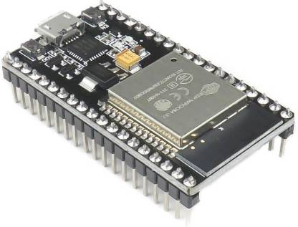

**Figure 3.2:** ESP32 Microcontroller

**Features:**

**1**.**Processors:**

* CPU: Xtensa dual-core (or single-core) 32-bit LX6 microprocessor, operating at 160 or 240 MHz and performing at up to 600 DMIPS
* Ultra low power (ULP) co-processor

**2**.**Wireless connectivity:**

* + Wi-Fi: 802.11 b/g/n
  + Bluetooth: v4.2 BR/EDR and BLE (shares the radio with Wi-Fi)

**3**.**Peripheral interfaces:**

* + 34 × programmable GPIOs
  + 12-bit SAR ADC up to 18 channels
  + 2 × 8-bit DACs
  + 10 × touch sensors (capacitive sensing GPIOs)
  + 4 × SPI
  + 2 × I²S interfaces
  + 2 × I²C interfaces
  + 3 × UART
  + oSD/SDIO/CE-ATA/MMC/ eMMC host controller
  + SDIO/SPI slave controller
  + Ethernet MAC interface with dedicated DMA and planned IEEE 1588 Precision

Time

* + CAN bus 2.0
  + Infrared remote controller (TX/RX, up to 8 channels)
  + LED PWM (up to 16 channels)
  + Hall effect sensor
  + Ultra low power analog pre-amplifier

**4.Security:**

* + IEEE 802.11 standard security features all supported, including WPA,WPA2,WPA3 (depending on version) [5] and WLAN Authentication and Privacy Infrastructure (WAPI)
  + Secure boot
  + Flash encryption
  + 1024-bit OTP, up to 768-bit for customers
  + Cryptographic hardware acceleration: AES, SHA-2, RSA, elliptic curve

**5**.**Power management**:

* + Internal low-dropout regulator
  + Individual power domain for RTC
  + 5 μA deep sleep current
  + Wake up from GPIO interrupt, timer, ADC measurements, capacitive touch sensor

Interrupt.

**3.4.2 PIR Sensor**

This PIR (Passive Infra-Red) Sensor is a pyroelectric device that detects motion by measuring changes in the infrared (heat) levels emitted by surrounding objects. This motion can be detected by checking for a sudden change in the surrounding IR patterns. When motion is detected the PIR sensor outputs a high signal on its output pin. This logic signal can be read by a microcontroller or used to drive a transistor to switch a higher current load.

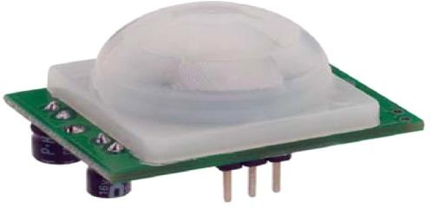

**Figure 3.3:** PIR Sensor Module

**Features**

Detection ranges up to 20 feet away Single bit output Jumper selects single or continuous trigger output mode 3-pin SIP header ready for breadboard or through hole. Product size makes it easy to conceal Compatible with BASIC Stamp, Propeller, and many other microcontrollers.

**Key Specifications Of Pir Sensor**

* Power requirements: 3.3 to 5 VDC; >3 mA (may vary)
* Communication: Single bit high/low output
* Operating temperature: 32 to 122 °F (0 to 50 °C)
* Dimensions: 1.27 x 0.96 x 1.0 in (32.2 x 24.3 x 25.4 mm)

**PIR Pin Definition and Ratings:**

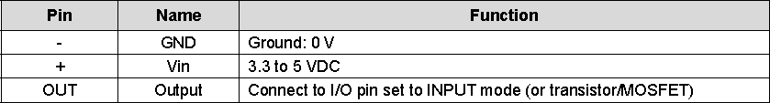

**Table 3.1:** Pin Configuration of PIR sensor

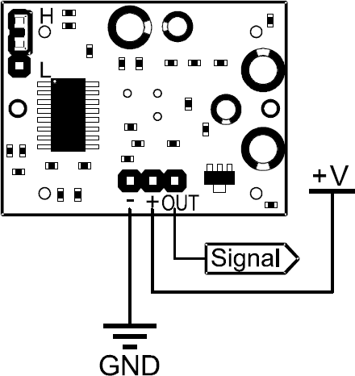

**Figure 3.4:** Pin diagram of PIR Sensor

* + 1. **Ultrasonic Sensor**

Ultrasonic sensors work on a principle similar to sonar which evaluates distance of a target by interpreting the echoes from ultrasonic sound waves. This ultrasonic module measures the distance accurately which provides 0cm - 400cm with a gross error of 3cm. Its compact size, higher range and easy usability make it a handy sensor for distance measurement and mapping. The module can easily be interfaced to micro controllers where the triggering and measurement can be done using two pin. The sensor transmits an ultrasonic wave and produces an output pulse that corresponds to the time required for the burst echo to return to the sensor. By measuring the echo pulse width, the distance to target can easily be calculated. Features non-contact measurement with blinding from 0-1cm*.

**Feature:**

* Easy to use 4-pin break-out.
* Range- 2cm to 400cm non-contact measurement function.
* Ranging Accuracy-+ or – 3cm.
* Measure Angle- 15 deg
* Operating voltage- 5v
* Operating temperature range 0C to 60C
* Separate input for echo and trigger input.

**Pin Descrption:**

With the sensor as shown in Figure 3.5, locate Pin-1 as the 1st pin on the left hand side.

[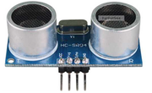](http://www.robosoftsystems.co.in/wikidocs/index.php?title=File:Ultra2.png)

**Figure 3.5:** Ultrasonic Sensor

|  |  |
| --- | --- |
| **Pin No.** | **Signal** |
| 1 | VCC (5V supply) |
| 2 | Trigger Pulse Input |
| 3 | Echo Pulse Output |
| 4 | GND (0V) |

**Table 3.2:** Pin Configuration of Ultrasonic Sensor

**Specifications**

|  |  |
| --- | --- |
| **Parameter** | **Specification** |
| **Dimensions** | 45 x 20 x 15 mm (± |
| **Pin-out Pitch** | 2.54mm male berg |
| **Interface** | VCC, GND, SDA,SCL |

**Table 3.3:** Specification of Ultrasonic Sensor

**3.4.3.1 Operation:**

The Timing diagram is shown below. You only need to supply a short 10uS pulse to the trigger input to start the ranging, and then the module will send out an 8 cycle burst of ultrasound at 40 kHz and raise its echo. The Echo is a distance object that is pulse width and the range in proportion.You can calculate the range through the time interval between sending trigger signal and receiving echo signal.

Formula: uS / 58 = centimeters or uS / 148 =inch;or: range = high level time * velocity (340M/S) / 2;

[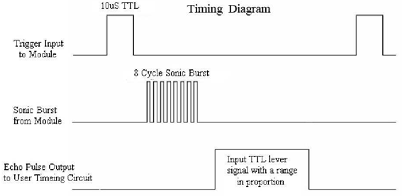](http://www.robosoftsystems.co.in/wikidocs/index.php?title=File:Ultra1.png)

**Figure 3.6:** Timing Diagram

**Note:-**

* The module is not suggested to connect directly to live supply, if connected, the GND terminal should be connected to the module first, otherwise, it will affect the normal work of the module.
* When testing objects, the range of area should not be less than 0.5 square meters and the surface plane as smooth as possible, otherwise, it will affect the results of measuring.

**3.4.4 Power Supply**

Power supply is a reference to a source of electrical pow. A device or system that supplies electrical or other types of energy to an output load or group of loads is called a power supply unit or PSU. The term is most commonly applied to electrical energy supplies, less often to mechanical ones, and rarely to others.

Power supplies for electronic devices can be broadly divided into linear and switching power supplies. The linear supply is a relatively simple design that becomes increasingly bulky and heavy for high current devices; voltage regulation in a linear supply can result in low efficiency. A switched-mode supply of the same rating as a linear supply will be smaller, is usually more efficient, but will be more complex.

**3.4.4.1 Linear Power Supply**

An [AC](http://en.wikipedia.org/wiki/Alternating_current) powered linear power supply usually uses a [transformer](http://en.wikipedia.org/wiki/Transformer) to convert the voltage from the wall outlet (mains) to a different, usually a lower voltage. If it is used to produce [DC](http://en.wikipedia.org/wiki/Direct_current), a [rectifier](http://en.wikipedia.org/wiki/Rectifier) is used. A [capacitor](http://en.wikipedia.org/wiki/Capacitor) is used to smooth the pulsating current from the rectifier. Some small periodic deviations from smooth direct current will remain, which is known as [ripple.](http://en.wikipedia.org/wiki/Ripple_(electrical)) These pulsations occur at a frequency related to the AC [power frequency](http://en.wikipedia.org/wiki/Utility_frequency) (for example,a multiple of 50 or 60 Hz).

The voltage produced by an unregulated power supply will vary depending on the load and on variations in the AC supply voltage. For critical electronics applications a [linear regulator](http://en.wikipedia.org/wiki/Linear_regulator) will be used to stabilize and adjust the voltage. This regulator will also greatly reduce the ripple and noise in the output direct current. Linear regulators often provide current limiting, protecting the power supply and attached circuit from over current.

Adjustable linear power supplies are common laboratory and service shop test equipment, allowing the output voltage to be set over a wide range. For example, a bench power supply used by circuit designers may be adjustable up to 30 volts and up to 5 amperes output. Some can be driven by an external signal, for example, for applications requiring a pulsed output.

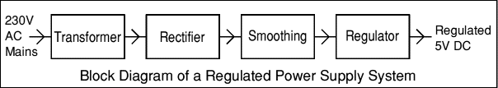

**Figure 3.7:** Power Supply

**3.4.4.2 Transformer**



**Figure 3.8:** Transformer

Transformers convert AC electricity from one voltage to another with little loss of power. Transformers work only with AC and this is one of the reasons why mains electricity is AC. Step-up transformers increase voltage, step-down transformers reduce voltage. Most power supplies use a step-down transformer to reduce the dangerously high mains voltage (230V in UK) to a safer low voltage.

The input coil is called the primary and the output coil is called the secondary. There is no electrical connection between the two coils; instead they are linked by an alternating magnetic field created in the soft-iron core of the transformer. The two lines in the middle of the circuit symbol represent the core. Transformers waste very little power so the power out is (almost) equal to the power in.Note that as voltage is stepped down current is stepped up. The ratio of the number of turns on each coil, called the turn’s ratio, determines the ratio of the voltages. A step-down transformer has a large number of turns on its primary (input) coil which is connected to the high voltage mains supply, and a small number of turns on its secondary (output) coil to give a low output voltage.

Turns ratio=Vp/Vs=Nn/Ns and

Power out=Power in Vs*Is=Vp * Ip

|  |  |
| --- | --- |
| Vp = primary (input)  voltage  Np = number of turn on  Primary coil  Ip = Primary (input)  current | Vs= secondary (output)  voltage  Ns = number of turns on  secondary coil  Is = secondary (output)  current |

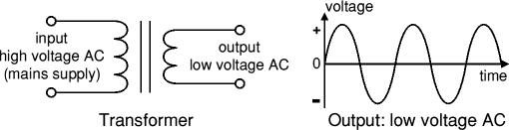

**Figure 3.9:** Output Signals

The low voltage AC output is suitable for lamps, heaters and special AC motors. It is not suitable for electronic circuits unless they include a rectifier and a smoothing capacitor.

**3.4.4.3 Rectifier:**

There are several ways of connecting diodes to make a rectifier to convert AC to DC. The [bridge rectifier](http://www.kpsec.freeuk.com/powersup.htm#bridgerectifier) is the most important and it produces full-wave varying DC. A full-wave rectifier can also be made from just two diodes if a centre-tap transformer is used, but this method is rarely used now that diodes are cheaper. A [single diode](http://www.kpsec.freeuk.com/powersup.htm#singlediode) can be used as a rectifier but it only uses the positive (+) parts of the AC wave to produce half-wave varying DC.

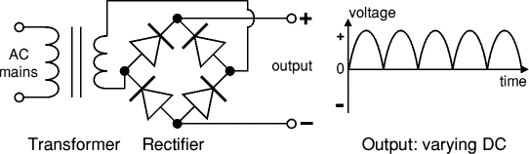

**Figure 3.10:** Rectifier

The varying DC output is suitable for lamps, heaters and standard motors. It is not suitable for electronic circuits unless they include a smoothing capacitor.

**3.4.4.3.1 Bridge Rectifier:**

A bridge rectifier can be made using four individual diodes, but it is also available in special packages containing the four diodes required. It is called a full-wave rectifier because it uses the entire AC wave (both positive and negative sections). 1.4V is used up in the bridge rectifier because each diode uses 0.7V when conducting and there are always two diodes conducting, as shown in the diagram below. Bridge rectifiers are rated by the maximum current they can pass and the maximum reverse voltage they can withstand (this must be at least three times the supply [RMS](http://www.kpsec.freeuk.com/acdc.htm#rms) voltage so the rectifier can withstand the peak voltages). Please see the [Diodes](http://www.kpsec.freeuk.com/components/diode.htm#bridge) page for more details, including pictures of ridge rectifiers.

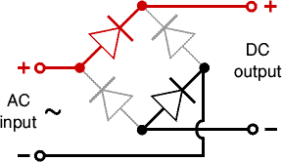

**Figure 3.11:** Bridge Rectifier

Alternate pairs of diodes conduct, changing over the connections so the alternating directions of AC are converted to the one direction of DC.

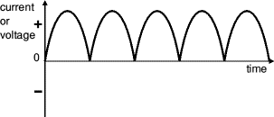

**Figure 3.12:** Output Waveform

**3.4.4.3.2 Single Diode Rectifier:**

A single diode can be used as a rectifier but this produces **half-wave** varying DC which has gaps when the AC is negative. It is hard to smooth this sufficiently well to supply electronic circuits unless they require a very small current so the smoothing capacitor does not significantly discharge during the gaps. Please see the [Diodes](http://www.kpsec.freeuk.com/components/diode.htm#rectifier) page for some examples of rectifier diodes.

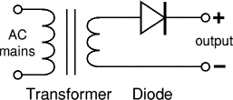

**Figure 3.13:** Single Diode Rectifier

Output: half-wave varying DC (using only half the AC wave):

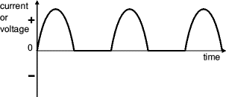

**Figure 3.14:** Output Signals

**3.4.4.4 Smoothing:**

Smoothing is performed by a large value electrolytic capacitor connected across the DC supply to act as a reservoir, supplying current to the output when the varying DC voltage from the rectifier is falling. The diagram shows the unsmoothed varying DC (dotted line) and the smoothed DC (solid line). The capacitor charges quickly near the peak of the varying DC, and then discharges as it supplies current to the output.

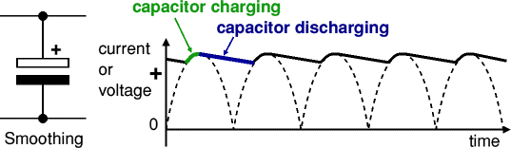

**Figure 3.15:** Smoothing Effect

Note that smoothing significantly increases the average DC voltage to almost the peak value (1.4 × [RMS](http://www.kpsec.freeuk.com/acdc.htm#rms) value). For example 6V RMS AC is rectified to full wave DC of about 4.6V RMS (1.4V is lost in the bridge rectifier), with smoothing this increases to almost the peak value giving 1.4 × 4.6 = 6.4V smooth DC.

Smoothing is not perfect due to the capacitor voltage falling a little as it discharges, giving a small ripple voltage. For many circuits a ripple which is 10% of the supply voltage is satisfactory and the equation below gives the required value for the smoothing capacitor.

Smoothing Capacitor for 10% ripple, C=5*10/vs.*f

C = smoothing capacitance in farads (F)

Io = output current from the supply in amps (A)

Vs = supply voltage in volts (V), this is the peak value of the unsmoothed DC

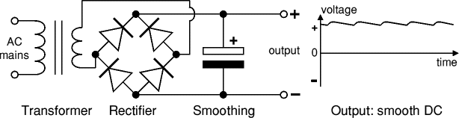 F = frequency of the AC supply in hertz (Hz), 50Hz in the UK.

**Figure 3.16:** Power Supply

**3.4.5 Regulator:**

Voltage regulator ICs are available with fixed (typically 5, 12 and 15V) or variable output voltages. They are also rated by the maximum current they can pass. Negative voltage regulators are available, mainly for use in dual supplies.

The LM78XX series of three terminal regulators is available with several fixed output voltages making them useful in a wide range of applications. One of these is local on card regulation, eliminating the distribution problems associated with single point regulation. The voltages available allow these regulators to be used in logic systems, instrumentation, HiFi, and other solid state electronic equipment. Although designed primarily as fixed voltage regulators these devices can be used with external components to obtain adjustable voltages and current.

Many of the fixed voltage regulator ICs has 3 leads and look like power transistors, such as the 7805 +5V 1A regulator shown on the right. They include a hole for attaching if necessary.

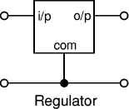

**Figure 3.17:** Regulator

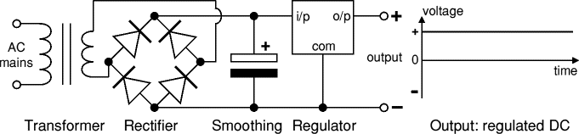

**Figure 3.18:** Output Power supply With Signals

**3.4.6 Buzzer**

A **buzzer** or **beeper** is a signalling device, The word "buzzer" comes from the rasping noise that buzzers made when they were electromechanical devices, operated from stepped-down AC line voltage at 50 or 60 cycles. Other sounds commonly used to indicate that a button has been pressed are a ring or a beep.

This novel buzzer circuit uses a relay in series with a small audio transformer and speaker. When the switch is pressed, the relay will operate via the transformer primary and closed relay contact. As soon as the relay operates the normally closed contact will open, removing power from the relay, the contacts close and the sequence repeats, all very quickly...so fast that the pulse of current causes fluctuations in the transformer primary, and hence secondary. The speakers tone is thus proportional to relay operating frequency. The capacitor C can be used to "tune" the note. The nominal value is 0.001uF, increasing capacitance lowers the buzzers tone.

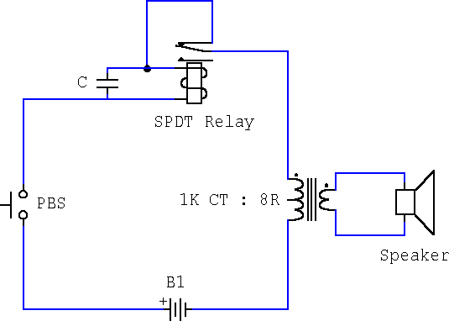

**Figure 3.19:** Buzzer Circuit

**3.5 Software Description**

**3.5.1 Arduino IDE**

The Arduino Integrated Development Environment - or Arduino Software (IDE) - contains a text editor for writing code, a message area, a text console, a toolbar with buttons for common functions and a series of menus. It connects to the Arduino and Genuino hardware to upload programs and communicate with them.

**3.5.1.1 WRITING SKETCHES IN ARDUINO IDE**

Programs written using Arduino Software (IDE) are called sketches. These sketches are written in the text editor and are saved with the file extension **.**ino. The editor has features for cutting/pasting and for searching/replacing text.

The message area gives feedback while saving and exporting and also displays errors. The console displays text output by the Arduino Software (IDE), including complete error messages and other information. The bottom right hand corner of the window displays the configured board and serial port. The toolbar buttons allow you to verify and upload programs, create, open, and save sketches, and open the serial monitor.

**3.5.1.2 Sketch book**

The Arduino Software (IDE) uses the concept of a sketchbook: a standard place to store your programs (or sketches). The sketches in your sketchbook can be opened from the File > Sketchbook menu or from the Open button on the toolbar. The first time you run the Arduino software, it will automatically create a directory for your sketchbook. You can view or change the location of the sketchbook location from with the Preferences dialog. Beginning with version 1.0, files are saved with a .ino file extension. Previous versions use the .pde extension. You may still open .pde named files in version 1.0 and later, the software will automatically rename the extension to .ino.Tabs, Multiple Files, and Compilation. Allows you to manage sketches with more than one file (each of which appears in its own tab). These can be normal Arduino code files (no visible extension), C files (.c extension), C++ files (.cpp), or header files (.h).

**3.5.1.3 Uploading The Code**

Before uploading your sketch, you need to select the correct items from the Tools >Board and Tools > Port menus. The [boards](https://www.arduino.cc/en/Guide/Environment#boards) are described below. On Windows, it's probably COM1 or COM2 (for a serial board)or COM4, COM5, COM7, or higher (for a USB board) - to find out, you look for USB serial device in the ports section of the Windows Device Manager. Once you've selected the correct serial port and board, press the upload button in the toolbar or select the Upload item from the File menu. Current Arduino boards will reset automatically and begin the upload. With older boards (pre-Diecimila) that lack auto-reset, you'll need to press the reset button on the board just before starting the upload. On most boards, you'll see the RX and TX LEDs blink as the sketch is uploaded. The Arduino Software (IDE) will display a message when the upload is complete, or show an error.

When you upload a sketch, you're using the Arduino bootloader, a small program that has been loaded on to the microcontroller on your board. It allows you to upload code without using any additional hardware. The bootloader is active for a few seconds when the board resets; then it starts whichever sketch was most recently uploaded to the microcontroller. The bootloader will blink the on-board (pin 13) LED when it starts.

**3.5.1.4 Libraries**

Libraries provide extra functionality for use in sketches, e.g. working with hardware or manipulating data. To use a library in a sketch, select it from the Sketch > Import Library menu. This will insert one or more #include statements at the top of the sketch and compile the library with your sketch.

Because libraries are uploaded to the board with your sketch, they increase the amount of space it takes up. If a sketch no longer needs a library, simply delete its #includestatements from the top of your code.

**3.5.2 Serial Monitor**

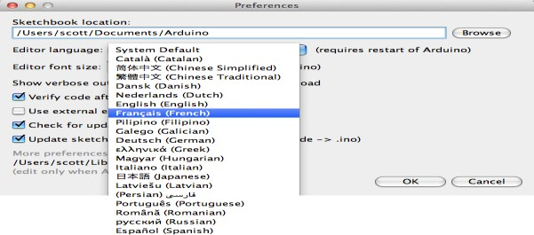 Displays serial data being sent from the Arduino or Genuino board (USB or serial board). To send data to the board, enter text and click on the "send" button or press enter. Choose the baud rate from the drop-down that matches the rate passed to Serial. Begin in your sketch. Note that on Windows, Mac or Linux, the Arduino or Genuino board will reset (rerun your sketch execution to the beginning) when you connect with the serial monitor.You can also talk to the board from Processing, Flash, Max MSP, etc (see the [interfacing page](http://www.arduino.cc/playground/Main/Interfacing) for details).

**Figure 3.20:** Sketch Diagram

Since version 1.0.1 , the Arduino Software (IDE) has been translated into 30+ different languages. By default, the IDE loads in the language selected by your operating system. (Note: on Windows and possibly Linux, this is determined by the locale setting which controls currency and date formats, not by the language the operating system is displayed in.)

If you would like to change the language manually, start the Arduino Software (IDE) and open the Preferences window. Next to the Editor Language there is a dropdown menu of currently supported languages. Select your preferred language from the menu, and restart the software to use the selected language. If your operating system language is not supported, the Arduino Software (IDE) will default to English.

**3.5.3 Embedded C**

**Embedded C** is a set of language extensions for the C Programming language by the C Standards committee to address commonality issues that exist between C extensions for different embedded systems. Historically, embedded C programming requires nonstandard extensions to the C language in order to support exotic features such as fixed-point arithmetic, multiple distinct memory banks, and basic I/O operations.

In 2008, the C Standards Committee extended the C language to address these issues by providing a common standard for all implementations to adhere to. It includes a number of features not available in normal C, such as, fixed-point arithmetic, named address spaces, and basic I/O hardware addressing.

Embedded C uses most of the syntax and semantics of standard C, e.g., main() function, variable definition, datatype declaration, conditional statements (if, switch, case), loops (while, for), functions, arrays and strings, structures and union, bit operations, macros, etc.

**3.5.4 Necessity**

During infancy years of microprocessor-based systems, programs were developed using assemblers and fused into the EPROMs. There used to be no mechanism to find what the program was doing. LEDs, switches, etc. were used to check for correct execution of the program. Some ‘very fortunate’ developers had In-circuit Simulators (ICEs), but they were too costly and were not quite reliable as well. As time progressed, use of microprocessor-specific assembly-only as the programming language reduced and embedded systems moved onto C as the embedded programming language of choice. C is the most widely used programming language for embedded processors/controllers. Assembly is also used but mainly to implement those portions of the code where very high timing accuracy, code size efficiency, etc. are prime requirements. As assembly language programs are specific to a processor, assembly language didn’t offer portability across systems. To overcome this disadvantage, several high level languages, including C, came up. Some other languages like PLM, Modula-2, Pascal, etc. also came but couldn’t find wide acceptance. Amongst those, C got wide acceptance for not only embedded systems, but also for desktop applications. Even though C might have lost its sheen as mainstream language for general purpose applications, it still is having a strong-hold in embedded programming.

**Advantages**

* It is small and simpler to learn, understand, program and debug.
* Compared to assembly language, C code written is more reliable and scalable, more portable between different platforms.
* C compilers are available for almost all embedded devices in use today, and there is a large pool of experienced C programmers.
* Unlike assembly, C has advantage of processor-independence and is not specific to any particular microprocessor/[microcontroller](https://en.wikipedia.org/wiki/Microcontroller) or any system. This makes it convenient for a user to develop programs that can run on most of the systems.

**3.5.5 Embedded Systems Programming**

Embedded systems programming is different from developing applications on a desktop computer. Key characteristics of an embedded system, when compared to PCs, are as follows: Embedded devices have resource constraints (limited ROM, limited RAM, limited stack space, less processing power)Components used in embedded system and PCs are different; embedded systems typically use smaller, less power consuming components. Embedded systems are more tied to the hardware.

Two salient features of Embedded Programmingare code speed and code size. Code speed is governed by the processing power, timing constraints, whereas code size is governed by available program memory and use of programming language. Goal of embedded system programming is to get maximum features in minimum space and minimum time. Embedded systems are programmed using different type of languages:

* + - * + Machine Code
        + Low level language, i.e., assembly
        + High level language like C, C++, Java, Ada, etc.
        + Application level language like Visual Basic, scripts, Access, etc.

Assembly language maps mnemonic words with the binary machine codes that the processor uses to code the instructions. Assembly language seems to be an obvious choice for programming embedded devices. However, use of assembly language is restricted to developing efficient codes in terms of size and speed. Also, assembly codes lead to higher software development costs and code portability is not there. Developing small codes are not much of a problem, but large programs/projects become increasingly difficult to manage in assembly language. Finding good assembly programmers has also become difficult nowadays.

**3.5.5.1 Difference Between C And Embedded C**

Though **C and embedded C** appear different and are used in different contexts, they have more similarities than the differences. Most of the constructs are same; the difference lies in their applications.

C is used for desktop computers, while **embedded C** is for microcontroller based applications. Accordingly, C has the luxury to use resources of a desktop PC like memory, OS, etc. While programming on desktop systems, we need not bother about memory. However, embedded C has to use with the limited resources (RAM, ROM, I/Os) on an embedded processor. Thus, program code must fit into the available program memory. If code exceeds the limit, the system is likely to crash.

Compilers for C (ANSI C) typically generate OS dependent executables. **Embedded C** requires compilers to create files to be downloaded to the microcontrollers/microprocessors where it needs to run. Embedded compilers give access to all resources which is not provided in compilers for desktop computer applications.

Embedded systems often have the real-time constraints, which is usually not there with desktop computer applications. Embedded systems often do not have a console, which is available in case of desktop applications.

So, what basically is different while programming with **embedded C** is the mindset; for embedded applications, we need to optimally use the resources, make the program code efficient, and satisfy real time constraints, if any. All this is done using the basic constructs, syntaxes, and function libraries of ‘C’.

**3.5.6 Proteus Software**

**Proteus** (**PRO**cessor for **TE**xt **E**asy to **US**e) is a fully functional, procedural programming language created in 1998 by Simone Zanella. Proteus incorporates many functions derived from several other languages: C, BASIC, Assembly, Clipper/dBase; it is especially versatile in dealing with strings, having hundreds of dedicated functions; this makes it one of the richest languages for text manipulation.

Proteus owes its name to a Greek god of the sea (Proteus), who took care of Neptune's crowd and gave responses; he was renowned for being able to transform himself, assuming different shapes. Transforming data from one form to another is the main usage of this language.

**3.5.6.1 Introduction**

Proteus was initially created as a multiplatform ([DOS](https://en.wikipedia.org/wiki/DOS), [Windows](https://en.wikipedia.org/wiki/Windows), [Unix](https://en.wikipedia.org/wiki/Unix)) system utility, to manipulate text and binary files and to create [CGI](https://en.wikipedia.org/wiki/Common_Gateway_Interface) scripts. The language was later focused on Windows, by adding hundreds of specialized functions for: network and serial communication, database interrogation, system service creation, console applications, keyboard emulation, [ISAPI](https://en.wikipedia.org/wiki/ISAPI) scripting (for [IIS](https://en.wikipedia.org/wiki/Internet_Information_Services)). Most of these additional functions are only available in the Windows flavor of the interpreter, even though a [Linux](https://en.wikipedia.org/wiki/Linux) version is still available.

Proteus was designed to be practical (easy to use, efficient, complete), readable and consistent.

* Its strongest points are:
* powerful string manipulation;
* comprehensibility of Proteus scripts;
* availability of advanced data structures: [arrays,](https://en.wikipedia.org/wiki/Array_data_structure) [queues](https://en.wikipedia.org/wiki/Queue_(data_structure)) (single or double), [stacks,](https://en.wikipedia.org/wiki/Stack_(data_structure)) [bit](https://en.wikipedia.org/wiki/Bit_array) [maps](https://en.wikipedia.org/wiki/Bit_array), [sets](https://en.wikipedia.org/wiki/Set_(computer_science)), [AVL trees](https://en.wikipedia.org/wiki/AVL_tree).
* The language can be extended by adding user functions written in Proteus or

[DLLs](https://en.wikipedia.org/wiki/Dynamic-link_library) created in C/[C++](https://en.wikipedia.org/wiki/C%2B%2B).

**3.5.6.2 Language Features**

At first sight, Proteus may appear similar to Basic because of its straight syntax, but similarities are limited to the surface:

* + - * + Proteus has a fully functional, procedural approach;
        + variables are untyped, do not need to be declared, can be local or public and can

be passed by value or by reference;

* + - * + all the typical control structures are available (if-then-else; for-next; while-

loop; repeat-until; switch-case);

* + - * + new functions can be defined and used as native functions.

**3.5.6.3 Synopsis and Licensing**

The main features of this language are:

* + - * + fully functional, procedural language;
        + multi-language support: Proteus is available in several languages (keywords and messages) no data types: all variables can be used as integer numbers, floating point numbers or strings; variables are interpreted according to the functions being applied – Proteus keeps different representations of their values between calls, to decrease execution time in case of frequent conversions between one type and the other;
        + no pre-allocated structures: all data used by Proteus are dynamically allocated at execution time; there are no limits on: recursion, maximum data size, number of variables, etc.;
        + no operators: Proteus is a completely functional language – there are no operators; thus, there is no ambiguity when evaluating expressions and parenthesis are not needed;
        + large library of predefined functions: Proteus is not a toy-language, it comes with hundreds of library functions ready to be used for working on strings, dates, numbers, for sorting, searching and so on;
        + advanced data access (DAO), pipes, Windows sockets, serial ports: in the Windows version, Proteus includes hundreds of system calls which are operating system-specific;
        + clear and comprehensible syntax: the names of the library functions resamble those of corresponding functions in C, Clipper/Flagship and Assembly; by using medium-length keywords, Proteus programs are very easy to understand;
        + native support for high-level data structures: arrays, queues (single or double), stacks, bit maps, sets, AVL trees are already available in Proteus and do not require additional code or libraries to be used.

**CHAPTER 4**

**RESULTS AND DISCUSSION**

In this Project, the improvement of a Smart Intrusion Detection System For Crop Protection the usage of green hardware and software program answers is addressed. The proposed machine should permit fascinated events to react immediately, as it should be and accurately to an intrusion. Also, it's far a completely essential tool, in particular for the farmers, that allows you to make sure an correct Intrusion tracking machine and on the equal time to lower the demise of intruding animals.

This included machine’s technique gives the important intimation for early Intrusion detection and assessment, enhancing the present-day repute of intrusion tracking and surveillance structures at a extra powerful neighborhood level.

The proposed machine is absolutely appropriate, appropriate and value powerful for intrusion detection in small farm lands, villages and mountain farm regions in which there's extra intrusion of animals. Another essential asset of this machine is using 2 sensors (Ultrasonic & PIR Sensor).

The sensor movements growth similarly the scenario repute statistics and therefore, lower very notably the fake alarm events. Thus, the machine is extra touchy and capable of discover whether or not a intrusion may also occur. The maximum revolutionary function of our paintings is the mixing of a massive-scale sensor for having small value, non-stop statistics to be had with smaller decision, collectively with on call for excessive-decision statistics received with a quick cellular sensor. This aggregate gives excessive first-class statistics, excessive decision, minimization of fake events, at the same time as maintaining the general value of the machine small sufficient to be deployable on massive scale.

Moreover, a completely essential aspect, concerning the early intrusion detection, is that the time is walking right away, that means that the intruder is coming near right away and on the spot, motion is required. Otherwise, the intruder can harm the vegetation of the farm land.

The farmer has to address a extraordinarily difficult task, considering that earlier than intrusion if it's far mentioned and intrusion is prevented it does now no longer value any misplaced to the farmers. If the motion is past due and the farm land is already intruded then it's far tough for the farmers to get the farm rid of intrusion and vegetation also are being damaged.

The proposed machine is primarily based totally round a unmarried module, however it's far effortlessly extendable to a bigger range of equal such modules, and gives a completely touchy and noticeably sturdy statistics, that lets in a completely quick and efficaciously detection, prevention and response to intrusion of farm lands.

**Hardware Model Implementation:**

This module is placed in the Farm lands. Let us consider a intruder say some animal

is approaching the farm land. The PIR sensor that is placed in the module gets activated first by detecting the movement of the intrusion by turning the sensor on. Then the Ultrasonic sensor turns on detection the distance at which the intrusion is approaching which later used for the variation if intensity of the buzzer. The buzzer is driven by the sensors and starts buzzing. The microcontroller used to drive all the components is ESP32 which is easy to integrate and is cost efficient. Then that alarm or message is sent to the owner(farmer) using blynk app and this communication is achieved through Internet Of Things.

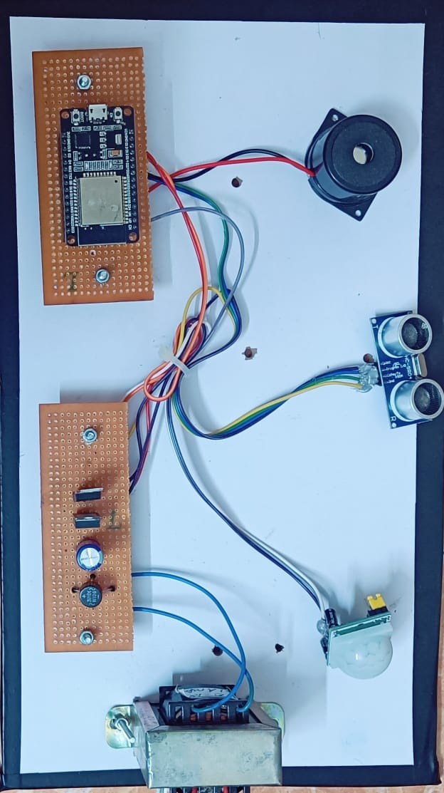**Prototype Model:**

**Figure 4.1:** Hardware Prototype model

|  |  |  |
| --- | --- | --- |
| **SENSOR** | **SENSOR ON – OUTPUT**  **(DISPLAY MESSAGE)** | **SENSOR ON – OUTPUT**  **(DISPLAY MESSAGE)** |
| Ultrasonic Sensor | Object Identified | Everything normal in land |
| PIR Sensor | Animal Detected | Everything normal in land |

**Table 4.1:** Hardware Prototype Output

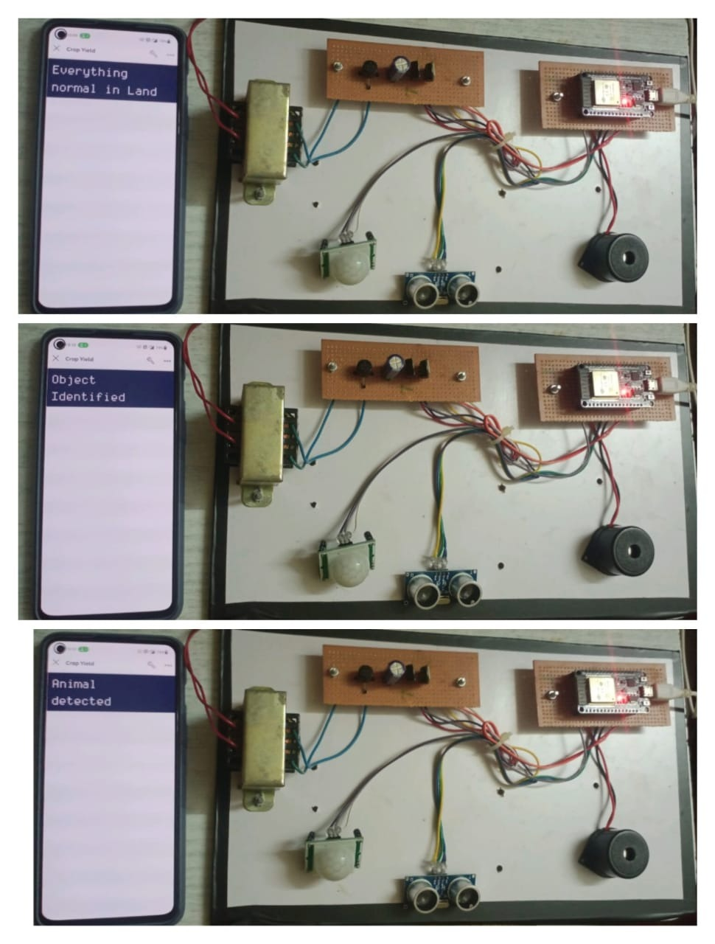

**Figure 4.2:** Implementation and results of Hardware Prototype model

The Ultrasonic sensor and the PIR sensor present in the hardware model is used to detect the distance and the movement of the Intruder respectively. When the Ultrasonic sensor is activated the message “Object Identified” is displayed on the blynk app and if the PIR sensor is activated the message “Animal detected” will be displayed on the app. If no intrusion is sensed in the land, then the message “Everything normal in land” will be displayed. All these results are shown in the figure 4.2 and table 4.1.

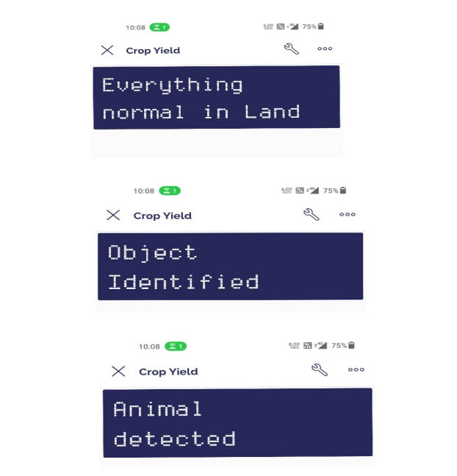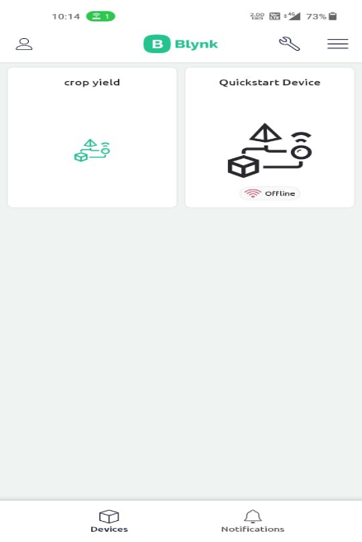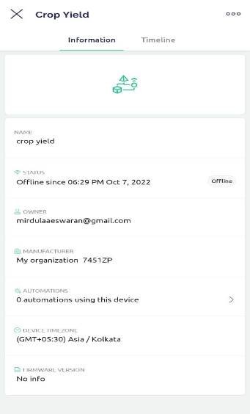

**Figure 4.3:** Software

In the figure 4.3 the screen of blynk app is shown. The proposed system’s hardware module is linked to this application through IOT which is used as the medium of communication. All the sensors are integrated in to the “crop yield” module present in the blynk application. When the mobile device is interfaced with the hardware module the status is updated from offline to online and the module starts functioning.

**CHAPTER 5 CONCLUSION**

The development in current agricultural can assist crop to develop efficiently. It is tough to keep in mind if automation device is green or now no longer in a greenhouse. The measured facts aren’t so correct to make the intelligence decision. The trouble of crop safety via way of means of wild animals has end up a chief social trouble withinside the contemporary-day time. It calls for pressing interest and a powerful answer. In this undertaking, an integrative method withinside the discipline of Internet of Things for clever Agriculture primarily based totally on low electricity gadgets and open-supply structures has been presented. The device prevents the lack of vegetation and to guard the region from intruders and wild animals which pose a chief chance to the rural areas. Also Save them from full-size economic losses and could store them from the unproductive efforts that they undergo for the safety their fields. This may also assist them in accomplishing higher crop yields as a consequence main to their monetary wellbeing.

**REFERENCES**

[1]Y. Elad, Y. Messika, M. Brand, D. Rav David, and A. Sztejnberg, "Effect of microclimate on Leveillula taurica Powdery mildew of sweet pepper," Phytopathology, vol. 97, no. 7, pp. 813-824, July 2019.

[2]K.L. Pernezny, P.D. Roberts, J.F. Murphy, and N.P. Goldberg, Compendium of Pepper Diseases, Wisconsin: American Phytopathological Society, 2016, ch. 1.

[3]S.F. Gennaro, L. Albanese, M. Benanchi, S.D. Marco, L. Genesio, A. Matese, et al., "An UAV-based remote sensing approach for the detection of spatial distribution and development of a grapevine trunk disease," in Proc. 8th International Workshop on Grapevine Trunk Diseases, Spain, 2019, pp. 734-737.

[4] D. Moshou, C. Bravo, R. Oberti, J.S. West, H. Ramon, S. Vougioukas, et al., "Intelligent multi-sensor system for the detection and treatment of fungal diseases in arable crops," Biosystems Engineering, vol. 108, no. 4, pp. 311–321, Apr. 2016.

[5] S.K. Pilli, B. Nallathambi, S.J. George, and V. Diwanji, "eAGROBOTA Robot for Early Crop Disease Detection using Image Processing," in Proc. IEEE International Conference on Electronics and Communication Systems, India, 2014.

[6] M.P. Groover, M.Weiss, R.N. Nagel, and N.G. Odrey, Industrial Robotics: Technology, Programming, and Applications, McGraw-Hill Higher Education, 2014

[7] R. Gonzalez, F. Rodriguez, J. Sanchez-Hermosilla, and J.G. Donaire, "Navigation Techniques for Mobile Robots in Greenhouses," Applied Engineering in Agriculture, vol. 25, no. 2, pp. 153-165, Mar. 2016.

[8] E.J. Van Henten, J. Hemming, B.A.J. Van Tuijl, J.G. Kornet, J. Meuleman, J. Bontsema, and E.A. Van Os, E. A. "An autonomous robot for harvesting cucumbers in greenhouses," Autonomous Robots, vol. 13, no. 3, pp. 241–258, Nov. 2012.

[9] S. Sankaran, A. Mishra, R. Ehsani, and C. Davis, "A review of advanced techniques for detecting plant diseases," Computers and Electronics in Agriculture, vol. 72, no. 1, pp. 1–13, June 2019.

[10] A. Barbedo, and J. Garcia, "Digital image processing techniques for detecting, quantifying and classifying plant diseases," SpringerPlus, vol. 2, pp. 660, Dec. 2018.

[11] J.D. Pujari, R. Yakkundimath, and A.S. Byadgi, "Image Processing Based Detection of Fungal Diseases in Plants," in Proc. International Conference on Information and Communication Technologies, India, 2015, pp. 1802–1808.

[12] J.K. Patil, and R. Kumar, "Advances in image processing for detection of plant diseases," Journal of Advanced Bioinformatics Applications and Research, vol. 2, no. 2, pp. 135-141, June 2011.

[13] N. Schor, S. Berman, A. Dombrovsky, Y. Elad, T. Ignat, and A. Bechar, "Perception apparatus design for a robotic system for greenhouse pepper disease detection," Precision Agriculture, submitted for publication.

[14] L. Bagnasco, M. Zotti, N. Sitta, and P. Oliveri, "A PCA-based hyperspectral approach to detect infections by mycophilic fungi on dried porcini mushrooms (boletus edulis and allied species)," Talanta, vol. 144, pp. 1225-1230, Nov. 2015.

[15] T. Rumpf, A.K. Mahlein, U. Steiner, E.C. Oerke, H.W. Dehne, and L. Plümer, "Early detection and classification of plant diseases with Support Vector Machines based on hyperspectral reflectance," Computers and Electronics in Agriculture, vol. 74, no. 1, pp. 91-99, Oct. 2010.